Project Title
“AI-Driven Women Safety Surveillance System with Real-Time Alerts and Emergency Response”

1. Problem Statement
In many regions, women's safety in public spaces remains a serious concern, especially during nighttime. Incidents often go unreported due to the absence of immediate monitoring, timely alerts, or effective response mechanisms. Women who are alone at night or surrounded by groups of men may face a heightened risk of harassment or violence, especially in high-risk zones.
There is a critical need for a real-time, intelligent surveillance solution that can detect potentially dangerous situations and trigger automatic alerts to authorities or guardians, reducing response time and increasing safety.

2. Project Description and Importance
This project develops a comprehensive surveillance system that:
- Uses real-time video monitoring via a camera.
- Detects faces, determines gender and age.
- Identifies danger-prone conditions such as a woman being alone at night or surrounded by multiple men.
- Recognizes distress gestures using hand tracking.
- Sends alerts via SMS and MQTT when threats are detected.
- Logs events in a MySQL database for analytics.
This system empowers surveillance with AI-driven automation and rapid emergency notification, significantly enhancing situational awareness and proactive safety measures.

3. Proposed Solution:
Feature | Description
Face Detection | Detects faces from the camera feed using OpenCV DNN.
Gender & Age Detection | Uses deep learning models to identify age and gender.
Rule-based Danger Logic | Triggers alerts when women are alone at night or surrounded by men.
Gesture Detection | Recognizes distress gestures using MediaPipe and a trained classifier.
Danger Zone Identification | Identifies if the person is in a known danger area based on GPS data.
Alert System | Sends SMS (via Twilio) and MQTT alerts on threat detection.
Event Logging | Stores all events in MySQL for review and analytics.

4. Technical Implementation
Hardware Requirements
- Webcam or USB camera – For real-time video input.
- Raspberry Pi / Laptop / Desktop – For processing and running detection models.
- GPS Module (optional) – For mobile deployments to identify danger zones.
Software & Frameworks
Tool/Framework | Purpose
Python | Core programming language
OpenCV | Video capture, face detection, age/gender classification
MediaPipe | Hand tracking and gesture recognition
Twilio API | Send SMS alerts
paho-mqtt | IoT alerts via MQTT protocol
MySQL | Store safety events and logs
pickle | Load gesture recognition ML model

5. Cloud & Backend Technologies
Layer | Technology | Role
Backend | MySQL | Stores surveillance event logs
Communication | MQTT Broker | Real-time telemetry and alerts
SMS Gateway | Twilio | Sends instant SMS alerts to emergency contacts
Edge Device | Raspberry Pi / Local System | Captures and processes live video locally

6. Algorithms and Methods Used:
6.1. Face Detection
- Algorithm: Haar Cascade Classifier
- Library: OpenCV
- Method: cv2.CascadeClassifier(...)
- Description: Used to detect human faces in video frames. It works by sliding a window over the image and applying multiple stages of classifiers to find face-like regions.

6.2. Age and Gender Classification
- Algorithm: Deep Neural Network (DNN) using Caffe Models
- Models Used:
  - age_net.caffemodel with age_deploy.prototxt
  - gender_net.caffemodel with gender_deploy.prototxt
- Library: OpenCV DNN module
- Description: Pretrained convolutional neural networks (CNNs) are used to predict:
  - Gender (Male/Female)
  - Age Group

6.3. Gesture Recognition
- Input Features: Hand landmarks
- Hand Tracking:
  - Library: MediaPipe Hands
  - Method: mp.solutions.hands
- Classifier Used:
  - Type: Custom-trained ML classifier (e.g., SVM)
  - Trained On: Labeled hand gesture data
  - Model File: gesture_model.pkl (saved using pickle)
- Output: Detects specific gestures like “Help” to trigger distress alerts.

6.4. Rule-Based Danger Logic
- Type: Conditional evaluation (no learning involved)
- Logic Conditions:
  - If 1 female detected alone at night
  - If 1 female is surrounded by ≥4 males
  - If distress gesture detected
- Action: Sends SMS via Twilio and publishes to MQTT.

6.5. Network Status Check (optional)
- Algorithm: Basic socket connection check
- Method: socket.create_connection(...)
- Purpose: Ensure internet is active for SMS/MQTT services

7. Frameworks Used:
Category | Framework / Library | Purpose
Computer Vision | OpenCV | For face detection, image preprocessing, and drawing annotations on frames.
Deep Learning Models | OpenCV DNN | For loading and running age and gender classification models (Caffe).
Hand Tracking | MediaPipe | For real-time hand landmark detection used in gesture recognition.
Machine Learning (ML) | scikit-learn (via pickle) | For training and loading gesture classifiers (e.g., SVM)
IoT Messaging | paho-mqtt | For publishing alert messages to MQTT brokers for IoT integration.
SMS Communication | Twilio | For sending real-time SMS alerts during safety violations.
Database Integration | mysql-connector-python | For storing event logs (gender counts, alerts) into a MySQL database.
Data Serialization | pickle | For loading pre-trained machine learning models (gesture_model.pkl).
Array Manipulation | NumPy | For array operations, especially with OpenCV DNN models.
Date/Time Processing | datetime | For checking night-time conditions (danger window).
Networking | socket | To check if network/internet is active for MQTT/Twilio communication.

8. Files to Download:
- age_deploy.prototxt
- age_net.caffemodel
- gender_deploy.prototxt
- gender_net.caffemodel
- gesture_model.pkl (trained ML model)
- GPS danger zones list (text file)

Link to download:
GitHub - Divyanshu-RS/Women-Safety-Analytics: Women Safety Analytics is a real-time monitoring system leveraging OpenCV and deep learning to detect potential threats, including gender distribution, unusual patterns, and SOS gestures. It enhances public safety by providing early alerts and valuable data for law enforcement.

9. Step-by-Step Installation and Setup:
Step 1: Install Required Python Libraries
Open your terminal or command prompt and install all required libraries:
pip install opencv-python, mediapipe, numpy, twilio, paho-mqtt, mysql-connector-python

Step 2: Download Age and Gender Detection Models
Download the following four files:
- age_deploy.prototxt
- age_net.caffemodel
- gender_deploy.prototxt
- gender_net.caffemodel
Place them in the same folder as your Python script.
Step 3: Set Up Twilio for SMS Alerts
- Create account at https://www.twilio.com
- Get account_sid, auth_token, and a Twilio phone number
- Update credentials in the code
twilio_client = Client("your_account_sid", "your_auth_token")
twilio_client.messages.create(body=alert, from_="+twilio_number", to="+91xxxxxxxxxx")

Step 4: Set Up MQTT Broker
A local broker
Update the IP and port in the code:
mqtt_client.connect("your_broker_ip", 1883)

Step 5: Set Up MySQL Database
- Install MySQL Server (e.g., XAMPP or MySQL CLI).
- Create a database and table:
CREATE DATABASE safety;
USE safety;
CREATE TABLE alerts (
id INT AUTO_INCREMENT PRIMARY KEY,
timestamp DATETIME,
males INT,
females INT,
status VARCHAR(255)
);

3.Update your Python code:
conn = mysql.connector.connect(
host="localhost",
user="root",
password="your_password",
database="safety"
)

Step 6: Run the Python Script

10. Full code:
import cv2
import numpy as np
import mediapipe as mp
import pickle
import datetime
import socket
import paho.mqtt.client as mqtt
from twilio.rest import Client
import mysql.connector
# Load Models
gender_net = cv2.dnn.readNet('gender_net.caffemodel', 'gender_deploy.prototxt')
age_net = cv2.dnn.readNet('age_net.caffemodel', 'age_deploy.prototxt')
model = pickle.load(open('gesture_model.pkl', 'rb'))
# MQTT & Twilio Setup
mqtt_client = mqtt.Client()
mqtt_client.connect("broker_ip", 1883)
twilio_client = Client("account_sid", "auth_token")
# MySQL Setup
conn = mysql.connector.connect(host="localhost", user="root", password="", database="safety")
cursor = conn.cursor()
# Camera and MediaPipe
cap = cv2.VideoCapture(0)
mp_hands = mp.solutions.hands
hands = mp_hands.Hands()
while True:
ret, frame = cap.read()
if not ret:
break

# Face Detection
gray = cv2.cvtColor(frame, cv2.COLOR_BGR2GRAY)
faces = cv2.CascadeClassifier(cv2.data.haarcascades + 'haarcascade_frontalface_default.xml').detectMultiScale(gray)
male_count = 0
female_count = 0
for (x, y, w, h) in faces:
face_img = frame[y:y+h, x:x+w]
blob = cv2.dnn.blobFromImage(face_img, 1, (227, 227), (78.426337, 87.768914, 114.895847), swapRB=False)
gender_net.setInput(blob)
gender = gender_net.forward().argmax()
age_net.setInput(blob)
age = age_net.forward().argmax()
label = f"{'Male' if gender==0 else 'Female'}, Age Group: {age}"
cv2.putText(frame, label, (x, y-10), cv2.FONT_HERSHEY_SIMPLEX, 0.7, (255,0,0), 2)
if gender == 0:
male_count += 1
else:
female_count += 1
# Time and Conditions
hour = datetime.datetime.now().hour
if 20 <= hour or hour <= 6:
if female_count == 1 and male_count == 0:
alert = "⚠ Alone at Night: Female Alone!"
mqtt_client.publish("safety/alert", alert)
twilio_client.messages.create(body=alert, from_="+twilio", to="+91xxxxxxxxxx")
elif female_count == 1 and male_count >= 4:
alert = f"🚨 ALERT: 1 Female surrounded by {male_count} Males!"
mqtt_client.publish("safety/alert", alert)
twilio_client.messages.create(body=alert, from_="+twilio", to="+91xxxxxxxxxx")
# Gesture Detection
rgb = cv2.cvtColor(frame, cv2.COLOR_BGR2RGB)
result = hands.process(rgb)
if result.multi_hand_landmarks:
for handLms in result.multi_hand_landmarks:
landmarks = [lm.x for lm in handLms.landmark] + [lm.y for lm in handLms.landmark]
pred = model.predict([landmarks])[0]
if pred == "Help":
alert = "🚨 Distress Gesture Detected!"
mqtt_client.publish("safety/alert", alert)
twilio_client.messages.create(body=alert, from_="+twilio", to="+91xxxxxxxxxx")

# Save to DB
cursor.execute("INSERT INTO alerts (timestamp, males, females, status) VALUES (NOW(), %s, %s, %s)",
(male_count, female_count, alert if 'alert' in locals() else 'Normal'))
conn.commit()
cv2.imshow("Women Safety Surveillance", frame)
if cv2.waitKey(1) & 0xFF == ord('q'):
break
cap.release()
cv2.destroyAllWindows()
if __name__ == "__main__":
main()

11. Prototype Demonstration
Scenario 1:
- Time: 10:30 PM
- Detected: 1 Female alone
- System sends:
  - MQTT alert: "⚠ Alone at Night: Female Alone!"
  - SMS alert to emergency contacts
Scenario 2:
- Time: 9:15 PM
- Detected: 1 Female, 4 Males
- Detected hand gesture: Distress
- System sends:
  - MQTT alert: "🚨 Distress Gesture Detected!"
  - SMS alert: "🚨 ALERT: 1 Female surrounded by 4+ Males!"
Visual Output:
- Live webcam feed with rectangles and labels (e.g., "Female, (25-32)")
- Danger messages shown on-screen and terminal logs

12. Console Output Sample:
✅ Connected to MQTT Broker!
✅ Connected to MySQL Database!
📹 Camera started...

📅 2025-07-01 20:15:32
🌐 Network: Online
👥 Detected: 5
⚠ Danger Area detected!
🚀 MQTT Alert Sent: ⚠ Danger Area Detected! Stay alert!
📩 SMS sent to +919361468480, SID: SM3a7a1xxxxxxxxxxxxxxxxxx
🚨 Distress Gesture Detected!
🚨 NIGHT DANGER: 1 Female + 4+ Males + Distress Gesture!
🚀 MQTT Alert Sent: 🚨 NIGHT DANGER: 1 Female + 4+ Males + Distress Gesture!
📩 SMS sent to +919361468480, SID: SMb56a0xxxxxxxxxxxxxxxxxx
📝 Logged to DB.

On the frame Face window (camera output):
- Bounding boxes with labels like:
Male, (25-32)
Female, (15-20)

- Overlays:
🚨 Surrounded by 4+ Males
⚠ Alone At Night

- Possibly:
🚨 Distress Gesture Detected!

Database Row Inserted (MySQL):
Sample entry inside safety_logs table:
id | timestamp | network_status | persons_detected | male_count | female_count | alert_message | alone_night | surrounded_by_men | distress_gesture | danger_area
1 | 2025-07-01 20:15:32 | Online | 5 | 4 | 1 | 🚨 NIGHT DANGER: 1 Female + 4+ Males + ... | 1 | 1 | 1 | 1

SMS Received by Guardian:
🚨 NIGHT DANGER: 1 Female + 4+ Males + Distress Gesture!
Location flagged as danger area. Immediate attention required.

13. Python Library Versions Used:
Library | Version
opencv-python | 4.9.0.80
mediapipe | 0.10.8
twilio | 8.10.0
paho-mqtt | 1.6.1
mysql-connector-python | 8.3.0
numpy | 1.26.4
pickle (standard lib) | Built-in
datetime, time, etc. | Built-in

These versions ensure compatibility with Python 3.8 to 3.11 and are tested to work well on both Raspberry Pi OS and Windows

14. System Architecture:
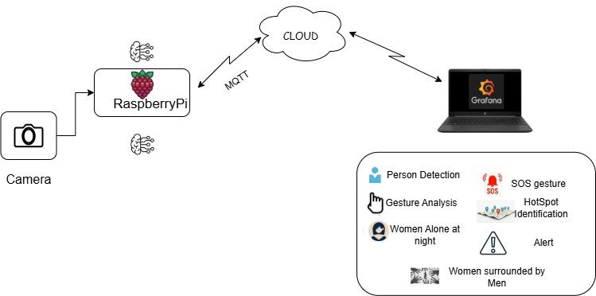

15. Grafana Dashboard:
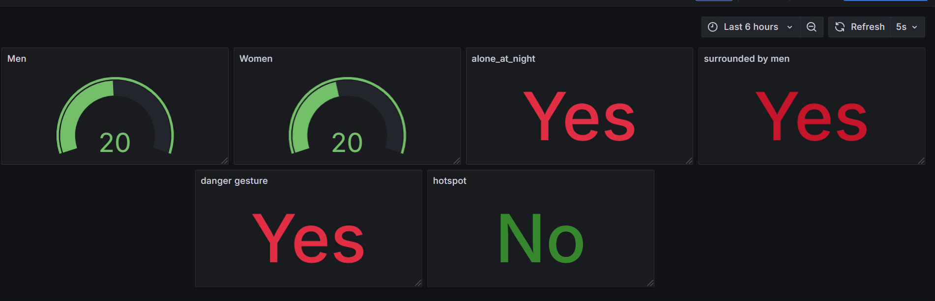

16. Impact and Benefits:
- Enhanced Real-time Safety Monitoring
- Rapid Emergency Alerts to Authorities/Contacts
- Rule-Based Threat Detection
- Data Logging for Policy and Safety Planning
- Scalable for Hostels, Bus Stops, Streets, Campuses
17.Future Scope:
Possible Improvements
- Better Camera for Night Use
- Smarter Gesture Detection
- Connect to a Mobile App
- Add Voice SOS Feature
- Work Without Internet
Next Steps for Further Development
- Improve the Detection System
- Build the Alert Feature
- Test in Real Places
- Add Data Tracking
- Make it Faster and Smarter

18.Conclusion:
This AI-powered women safety system is a proactive approach to addressing public safety challenges through computer vision, machine learning, and real-time IoT communication. The system is scalable, adaptable, and highly impactful for real-world deployment.

